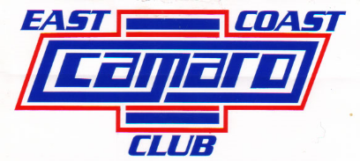
ANNUAL SHOW SPONSOR
P.O. Box 7172, Nashua, NH 03060-7172
EST. 1979, Incorporated
Dear Friend/Sponsor:
The East Coast Camaro Club, Inc. is planning our 45th Annual All Vehicle Show to be held at our NEW LOCATION, Hudson Hills House Field, 201 Derry Rd, Hudson NH, on Sunday, August 23rd, 2026. This is one show you will not want to miss!! Proceeds from the show will be donated to the Beth Israel Lahey Health at Home Hospice.
The Club is seeking businesses and individuals who wish to sponsor awards, Food Truck & product vendor space or donate door prizes.
AWARD SPONSOR for $50.00 you can sponsor 1 VEHICLE CLASS or SPECIALTY AWARD
Would you like to be a VENDOR at our show ??? Vendor spots are $ 75.00 , you will have your business listed on our sponsor section and on our website with a link to your website (if applicable). The proceeds will go to Beth Israel Lahey Health at Home Hospice.
VENDOR SPACE IS LIMITED SO SIGN UP EARLY FOR BEST SPOT!
If you would like to join us in this event by donating or becoming a sponsor for this worthy cause, please fill out the form below and return it as soon as possible. Make checks payable to:
E.C.C.C. P.O. Box 7172, Nashua, NH 03060-7172
For more information, contact: Louie Nocca 978-872-7442
Email: zeemanz67@verizon.net

(Please Print Clearly)
Sponsor's Name: Business Name:
Address: City: State: Zip:
Phone: _________________Sponsor's Signature:
$50 each CLASS or SPECIALTY AWARD SPONSOR. Qty _______
Vendor spots are $ 75.00 EACH (Due by August 9th, 2026. VENDOR SPOTS MUST BE PRE-PAID (NO EXCEPTIONS) !!!!!
OTHER WAYS TO HELP:
YES, I WOULD LIKE TO DONATE A DOOR PRIZE: (VALUE):
YES, I WOULD LIKE TO MAKE A CASH DONATION:
MEMBERS NAME (who gave you this flyer):
THANK YOU, E.C.C.C. 2026

