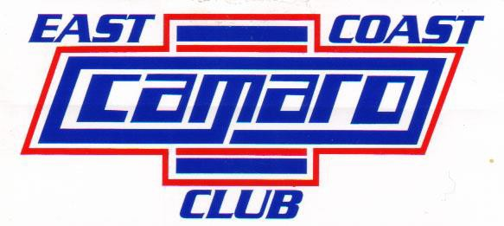
www.eastcoastcamaroclub.com P.O. BOX 7172, NASHUA, NH 03060

APPLICATION FOR MEMBERSHIP

DATE

NAME OF APPLICANT

STREET CITY STATE ZIP

PHONE E-MAIL

YR. OF CAR COLOR(S) BODY STYLE

NAME OF SPOUSE (AND/OR) FAMILY MEMBERS

LIST ANY SPECIAL INTERESTS YOU HAVE

REGULAR MEMBERSHIP $35.00 FOR ONE YEAR. REFERRED BY:

Please include a photo of your Camaro(s) for our member photo album. Also, from time to time the club gets requests for Camaros to be used in movies, ads, etc. Who knows, they may be looking for a Camaro just like yours!! If you have a digital photo you may e-mail it to: EastCoastCamaroClub@gmail.com.

Make CHECK OR M.O. TO: EAST COAST CAMARO CLUB and send it to:

ECCC – Membership
P.O. Box 7172
Nashua, NH 03060

www. EastCoastCamaroClub. com

